**INDUSTRY INTERNSHIP**

**ETII100**



**Name of Faculty: Dr SUBHASH CHAND GUPTA**

**Student Name: Survepalli Sreekruti**

**Roll No: A2305220266**

**AMITY SCHOOL OF ENGINEERING AND TECHNOLOGY**

**AMITY UNIVERSITY UTTAR PRADESH**

**NOIDA**

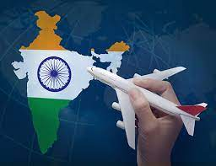

Indian Aviation Industry: An Overview



**Declaration**

I, **Survepalli Sreekruti**, student of B.Tech (6CSE1-X) hereby declare that the Industry internship project on **“Indian aviation sector”**,which is submitted by me to **Department of Computer Science & Engineering, Amity School of Engineering and Technology, Amity University, Noida, Uttar Pradesh**, in partial fulfilment of the requirements for the award of the degree of Bachelor of Technology in Computer Science & Engineering, & has not been previously submitted for the basis of the award in any other degree, diploma or any other recognition or title

DATE:

Survepalli Sreekruti

A2305220266

5CSE1Y (2020-24)

**certificate**

This is to certify that **Ms. Survepalli Sreekruti**, student of B. Tech in Computer Science & Engineering, has carried out work presented in the Industry internship project entitled “**Indian aviation sector**” as a part of her 6th year Program of Bachelor of Technology in Computer Science & Engineering from Amity University Noida,under my supervision.

I Dr. Subhash Chand Gupta

iDepartment of Computer Science & iEngineering

iASET

iNoida, Uttar Pradesh

**ACHNOWLEDGEMENT**

The completion of this project would be incomplete without the mention of people whose constant guidance has to be awarded with my success.

I would like to express my deep and sincere gratitude to my research supervisor, **Dr Subhash Chand Gupta,**for giving me the opportunity to do research on topic **“Indian aviation sector”** and providing invaluable guidance throughout this research. It was a great privilege and honour to work and study under her guidance. I would like to thank him for solving my queries and also guide me through out.

**index**

|  |  |  |
| --- | --- | --- |
| S. NO. | CONTENT | PAGE NO. |
| 1. | **INTRODUCTION**   * 1. Background   2. Literature Survey   3. Objective   4. Research Methodology   5. Limitations | 7-8 |
| 2. | **CONCEPTUAL FRAMEWORK**  2.1 Definition, Concepts and terms  2.2 National Scenario  2.3 Global Scenario  2.4 Foreign Equity Participation  2.5 Passenger Airlines-The Players | 9-10 |
| 3. | **MARKET SCENARIO**  3.1 Market Structure and Scenario  3.2 International & Domestic Civil Aviation Trends  3.3 Future Projected | 11-12 |
| 4. | Presentation of Data, Analysis and  Findings  Presentation of Data, Analysis and  Findings  **PRESENTATION OF DATA, ANALYSIS & FINDINGS**  4.1 Analysis of Operational efficiency  4.2 Analysis of Profitability ratio  4.3 Net Profitable Ratio  4.4 Contribution of Aviation Sector in the GDP  GDP | 12-16 |
| 5. | **CONCLUSION, RECCOMENDATIONS &**  **BIBLOGRAPHY**  5.1 Conclusion 5.2 Key Investments and Develoopments 5.3 Recommendation  5.4 Bibliography/ Reference  Conclusion , Recommendations and  Bibliography  Conclusion , Recommendations and  Bibliography  Conclusion , Recommendations and  Bibliography | 16 |

**Introduction**

**Background of the study**

It is a well-known truth that the aviation industry is a significant driver of economic growth, social development, and tourism in addition to providing enormous advantages to communities and economies all over the world. The majority of the Indian transportation network is made up of roads, highways, railroads, civil aircraft, and waterways. Prior to the pandemic (since 2020), India was the ninth-largest aviation market, with over 121 million domestic and 49 million international passengers.

On February 18, 1911, Henri Piquet flew a Humber biplane carrying 6,500 letters across a distance of six miles (nearly 9 KMS) between Allahabad and Naini, marking the first civil aviation flight in India. Civil aviation was initially a government-owned sector, but over time, things changed.

In recent years, it has been observed that the civil aviation sector in India has become one of the sectors with the fastest growth rates during the past three years. By 2024, India is predicted to surpass the UK to become the third-largest air passenger market, having risen to third place in the global domestic aviation industry. Considering that most of the population of the country still finds air travel to be expensive, India's aviation business is mostly unexplored and offers tremendous growth potential.

India now has 487 airports and airstrips, of which the AAI (Air India Authority) maintains 137 airports in total, including 24 international airports, 10 customs airports, and 103 domestic airports. The Airport Authority of India, a statutory agency that reports to the Directorate General of Civil Aviation in the Ministry of Civil Aviation, is in charge of developing, managing, and maintaining the country's civil aviation infrastructure.

**LITERATURE REVIEW**

**THE MINT: Rhik Kundu**- Executives in the civil aviation sector in India are upset with the Union budget because they feel that the government has not met the majority of their expectations. According to airline officials, the sector has been among the worst affected by the epidemic and associated movement limitations that have seriously hampered operations. High operating costs, particularly as a result of increased oil prices, are in addition to this. On condition of anonymity, a senior airline executive said, "While the industry was not anticipating financial assistance from the government, making provisions for tax breaks and eligibility for input tax credit would have gone a long way in helping the sector that has been under enormous financial stress due to the pandemic."

According to ratings firm Icra, India's aviation sector would post a net loss of $25,000–26,000 crore this fiscal year, and its debt will increase to $1.2 trillion. In the past year, the aviation industry has shed almost 7,900 jobs.

However, in recent years, the way that civil aviation is perceived has changed, and it is now considered as a crucial connection for connectivity to other parts of the country as well as for international travel and trade. The expansion of trade and tourism, the opening up of previously inaccessible areas of the country, the promotion of business activity, and economic growth are all significantly impacted by the aviation industry.

THE ECONOMIC TIMES: Airports set to come out of the red next fiscal; topline to jump

50%: Report march 28,2022

THE ECONOMIC TIMES: Airports set to come out of the red next fiscal; topline to jump

50%: Report march 28,2022

* **THE ECONOMIC TIMES: Airports set to come out of the red next fiscal; topline to jump 50%: Report March 28,2022**

Overall passenger traffic is expected to increase iby i68-70% over iFY22 to i317-320 million in FY23, while domestic passenger traffic is forecast to increase by 64-66% year over year and surpass pre-pandemic levels.

With the beginning of international commercial operations following a two-year hiatus due to the pandemic, international traffic is predicted to return to pre-pandemic levels in FY24, assuming ithere is ino fourth iwave or ithe impact of the inext wave will be ilimited.

Despite the brief disruption caused by the Omicron wave, ipassenger itraffic iis expected to rise iby i62–i64% to 187–189 million in FY22, backed by a healthy rate of immunisation. Returning international flights will hasten the recovery of air traffic, which will be fueled by travellers from iSoutheast Asia, ithe Middle East, and iEurope. It should be underlined that from the viewpoints of both aero and non-aero revenue, international travellers offer operators substantially greater yields. Over the next five years, the sector is expected to receive investments totaling more than Rs 90,000 crore, according to the research.

This includes ongoing capacity expansion at significant private airports, investments of Rs 25,000 crore by the Airports Authority in AAI-operated airports, Rs 30,000–34000 crore for the establishment of 21 new greenfield airports, and approximately Rs 17,000 crore by the Adani group to upgrade six airports it has taken over from the AAI.

* **THE MAHAN AIR’S CASE STUDY-“The impact of Expectation and Perception on Customer Satisfaction in Airline Industry**

They have discussed the discrepancy between consumer expectations and perceptions of services in their studies. They claimed that client expectations varied depending on educational attainment. Additionally, they claim that the discrepancy between consumer expectations and perceptions of airline service features enables senior managers to identify the services that are most crucial to customers and those that are compatible with their perceptions.

* **“Application of Customer Relationship Management in Airline Industry”- Mohammad. J. Tarokh and Mahmoud Majidi.**

Customer relationship management, in the opinion of Mohammad J. Tarokh and Mahmoud Majidi, is essential to the success of airline services. To meet the needs of their customers, marketers must comprehend their needs and desires. For this reason, developing positive relationships with clients is crucial. They discussed airline e-CRM, which helps airlines identify customer behaviour and track the effects of marketing adjustments. The cost of a client contact is decreased because to e-CRM, which facilitates totally digital information exchange between airlines and customers. Dynamically adjusting to client behaviour is also beneficial.

BUSINESS STANDARD: Government to release new policy framework to deepen air

connectivity in country. Aneesh Phadnis & Arindam Majumder March 24, 2022 23:19 IST

To improve air connectivity in the country, the Civil Aviation Ministry is preparing to announce a

new regulatory framework to encourage small aircraft and helicopter operations. Civil Aviation

Minister Jyotiraditya Scindia is likely to announce the light aircraft policy at the Wings India event

in Hyderabad on 25th March. The Ministry created the Udan regional connectivity project in 2016.

Under the Udan plan, almost 400 routes and 66 airports have been operationalized. While 50-70

seater ATR, Bombardier, or Embraer aircraft currently serve the Udan routes, the new policy will

accommodate small aircraft with 19 seats or less, seaplanes, and helicopters. The Ministry has also

proposed various approaches for states to disburse viability gap funds to make small plane and

helicopter operations financially feasible. Alliance Air, a government-owned company, has leased

two Dornier-228 aircraft with a capacity of 19 passengers, which it plans to use on routes in the

North East. Flying, a regional airline, also announced the signing of a letter of intent with De

Havilland Canada for the purchase of up to ten new 19-seater Twin Otter Series 400 aircraft

* **BUSINESS STANDARD: Government to release new policy framework to deepen air connectivity in country. Aneesh Phadnis & Arindam Majumder March 24, 2022**

IST The Civil Aviation Ministry is prepared to announce a new regulatory framework to promote small aircraft and helicopter operations in order to increase air connectivity in the nation. The announcement of the light aircraft policy is anticipated to be made by Civil Aviation Minister Jyotiraditya Scindia at the Wings India event in Hyderabad on March 25. The Udan regional connection project was developed by the Ministry in 2016. Nearly 400 routes and 66 airports have been put into service as part of the Udan strategy. The Udan routes are now served by 50–70 seater ATR, Bombardier, or Embraer aircraft, however the new policy will allow for small aircraft with 19 seats or fewer, seaplanes, and helicopters. In order to make small plane and helicopter operations financially viable, the Ministry has also recommended alternative methods for governments to provide viability gap money. Two Dornier-228 aircraft with a 19-passenger capacity have been leased by government-owned Alliance Air for usage on routes in the North East. Regional airline Flying also said that it has signed a letter of intent with De Havilland Canada to buy up to 10 brand-new 19-seater Twin Otter Series 400 planes.

* i**According** i**to** i**the** i**data** i**released** i**by the** i**Department** i**for** i**Promotion** i**of Industry and Internal Trade (DPIIT), FDI inflow in India’s air transport sector (including air freight) reached US$ 3.61 billion between April 2000-September 2022.**
* i**The** i**government** i**has** i**allowed** i**100%** i**FDI under the** i**automatic** i**route in scheduled air transport service, regional air transport service, and domestic scheduled passenger airlines. However, FDI over 49% would require government approval.**
* **Adani Airport Holdings (AAHL), which now manages six airports, received $250 million in May 2022 for capital expenses and the expansion of those airports.**
* **Tata Sons won the bidding war to buy state-run Air India in October 2021 by offering Rs. 18,000 crores (US$ 2.4 billion) to acquire 100% of the stock.**
* **The Ministry of Civil Aviation granted Akasa Air, a start-up airline, a "No Objection" permit to begin operations. The start-up started running in the middle of 2022.**

**OBJECTIVE**

Some of the study's aims are listed below: -

1.To determine the icontribution iof ithe iaviation isector to iIndia's iGDP

2.To assess the competitiveness of various airlines in the Indian aviation sector using comparative studies

3.To assess the short-term and long-term financial positions of airlines in the iIndian iaviation isector;

4. To determine the financial position of airlines in the Indian aviation sector.



**METHODOLOGY**

iThe imethodology iadopted in conducting the ipresent study are as follows:

**STEP1- DATA COLLECTION**

The study on Aviation sector in India was done on the basis of

SECONDARY DATA. Secondary data has contributed in a significant way to understand the

scope as well as it helped in developing the conceptual framework. The data has been

collected from various articles and websites for the completion of this project

On the basis of SECONDARY DATA, a study of the iaviation iindustry in iIndia was conducted. Understanding the breadth and creating the conceptual framework have both benefited significantly from the use of secondary data. To complete this research, the data was gathered from a variety of articles and websites.

**STEP2- REPRESENTATION OF DATA**

We have used simple graphs, pictures and tables to analyze and

to represent the collected data.

I have used simple graphs, pictures and tables to analyze and to represent the collected data.

**STEP3-TIME**

Data has been collected for the past 10 years ranging from 2010-11 to 2020- 2021

and has been shown in this project

Data has been collected for the past 10 years ranging from 2011-12 to 2021- 2022 and 2023 has been shown in this project.

**LIMITATIONS**

The study has been completed under certain limitations:

♣Lack of detailed study on this sector due to secondary source prospective.

♣The accuracy of the data collected.

♣Some of the data analysis on this sector are kept for its private members only so

presentation of such was not possible.

♣Lack of data availability on website.

FRAMEWORK

**CONCEPTUAL FRAMEWORK**

**DEFINITIONS:**

iMost ifrequently, imechanical iair itransportation ithat iutilises an iaeroplane is ireferred to as i"Aviation". iThe current iaviation iindustry's icontribution to ibridging icontinents, inations, and icultures is imade possible by its iglobalised character.

Thus, global aviation has been essential in providing efficient travel to remote areas and improving countless lives. The aviation business also directly supports millions of jobs for people all around the world, including jobs as pilots, cabin crew, air traffic controllers, and aerospace engineers. Additionally, the aviation industry has helped create a number of new jobs across the wider

**Concepts->**

**REGULATORY FRAMEWORK OF INDIAN CIVIL AVIATION SECTOR:**

iThere is a ineed for an iindependent iregulatory body that icould act as a iwatchdog, as iwell as a ifacilitator for the industryi, prescribei and enforcei minimumi standardsi for all iagencies, resolve disagreements regarding iabuse of imonopoly, and iensure level iplaying ifields for all agencies in the context of a multitude of iairlines, iairport operators, iincluding the iprivate sector. The CAA's mandate is to uphold a icompetitive civil aviationi environmenti that provides isafety and isecurity in iaccordance with iinternational istandards, encourages the iefficient, economical, and iorderly expansion of air travel, and supports the nation's social and economic development.

Objective of iCivil iAviation iMinistry-

1. iTo ensure iAviation safetyi and securityi
2. iEffective iRegulation of iAir Transporti in the countryi in a iliberalized environmenti
3. iSafe, Efficient, iReliable and iWidespread iQuality Air iTransport iServices are iprovided at iReasonable iprices
4. iFlexibility to iadapt to changes
5. Encourage Private Participation

India's civil aviation infrastructure has consistently grown and changed over time. The Indian federal government swiftly responded to evolving demands by creating new regulations or revising those that already exist, with the goal of advising market participants.

The governing bodies responsible for the safety and security of civil

aviation in India are:

The governing bodies iresponsible for the isafety and isecurity of icivil iaviation in iIndia are:

* **AERA (Airports Economic Regulatory Authority of India):**

iAirports iEconomic iRegulatory iAuthority of iIndia (AERA) was constituted by the Government of India as a statutory agency on May 12, 2009, by inotification No. iGSR 317(E). One of AERA's duties is to calculate the cost of aeronautical services while itaking into account icapital outlays and itimely investments in airport facility upgrades. The service offered, its calibre and other pertinent factors, the price to increase productivity, and the cost-effective and profitable operation of major airports.



* **Directorate General of Civil Aviation:**

Thei civil iaviation industry's iregulatory authority, the iDirectorate General of Civil Aviation (DGCA), focuses imostly on isafety-related imatters. It iis in charge of iregulating airi transportation iservices to, ifrom, and iwithin iIndia as well as the ienforcement of icivil aviation laws, iair safety istandards, and licences for pilots, aircraft maintenance engineers, and flight engineers. It also organises exams and checks for these purposes.

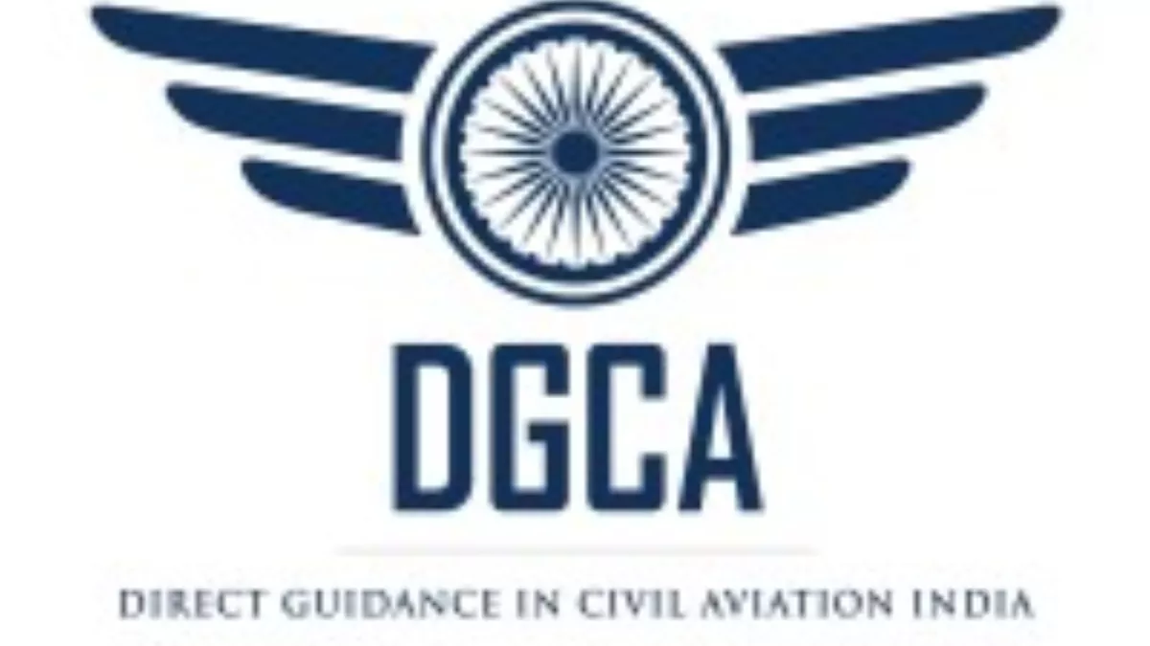

* **Bureau of Civil Aviation Security:**

On the advice of the iPande Committee, thei Bureaui of Civil Aviationi Security (BCAS) wasi first established as a Celli inside the DGCAi iin January 1978i. The primary duties of iBCAS includei settingi rulesi and regulations ifor the securityi of icivil flightsi at Indiani international and domestic airportsi. Planning and coordinating aviation security matters, imonitoring the application of securityi rulesi and regulationsi, and conducting a isurvey of securityi needsi. Assuring that those iimplementing securityi controlsi are properly trainedi and have all the skills necessary to carry out their dutiesi.



* **Aircraft Accident Investigation Bureau:**

The Governmenti iof India is authorised to establish regulations for the investigationi of accidentsi involving any aircraft that occur during or as a result of the inavigation in or iover Indiai of any iaircraft, or ianywhere of aircraft iregistered in iIndia, under Section 7 of the Aircraft Act of 1934. The Airi Safetyi Directoratei of the DGCAi previously handled the duties and responsibilities surrounding the iinvestigation of iaircraft accidents and iincidents in accordance with the iAct and in compliance with iArticle 26 of the iConvention on iInternational Civili Aviationi. The 1937 Aircraft Rules set the rules for this.The Aircraft (Investigationi of Accidentsi andi Incidentsi) Rules, 2012i were ideveloped and published in a iGazette Notificationi based on ICAOi SARPis iand the contexti of Indiani Civili Aviationi.

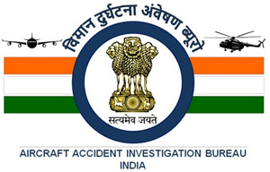

* **AAI (Airport Authority of India):**

The Directorate General of Civil Aviation, Ministry of Civil Aviation, Government of India, has authority over the AAI, which wasi establishedi by the Airportis Authorityi of iIndia Act, 1994i. The AAIi is in chargei of developing, enhancing, managing, and overseeing India's icivil aviationi infrastructurei. Over Indiani airspacei and nearby marine areas, it offers Communication Navigation Surveillance / Air Traffic Management services.



**OPEN SKIES POLICY:**

An Open Skies policy in civili aviationi refers to liberalisation, iease of access, and iterms of usagei for nationali airportsi by internationali carriersi. i It hasi been joined in order to boost touristi itraffic and maximise its potentiali as a regionali air hubi.

The Treaty on Open Skies is not in any wayi related ito civili aviationi and aims to improve "the mechanisms of control over military activities and of compliance with applicable arms control treaties" in order to foster "enhancement of confidence between the states." To put it another way, imember istates of the treatyi have ithe legal authorityi to fly over one another's full borders for military and political reasons.

For example, Russiai pursues thei open skiesi policy in the airportsi of iSochi, iKaliningrad and Vladivostoki. Israeli iis successfullyi usingi this policy iin its maini Ben Gurioni Airporti in Teli Aviv.

In other words, an open skies policy would permit any foreign airlinei, regardless of ownership or place of origin, ito landi at any porti as often as desired and with an unlimited number of passengers. iThere wouldi be noi limitations on the kind of iaircraft that may be usedi, noi requirement for certificationi, noi requirement for regular service, andi no requirement to identify the iairports where they iwould iland. Given this definition, it is not surprisingi thati only a small number of nations, typically those with just one or two airports and no national airlines, embrace open skies rules.

* **BILATERAL TREATIES:**

However, nearly all of the ICAO's members (99%) abide by the system of bilateral agreements that regulate iaviation relationsi betweeni two sovereign contractingi partiesi and are achievedi through negotiationi. In fact, it is believed that the bilateral aviation regime serves as the cornerstone of a disciplined and iregulated globali aviationi systemi.

It sets down the foundation for ownership, the number of seats that may be used, the kind and certification of the aircraft, as well as the ports of call that may be visited. It also governs operations through scheduled services. The bilateral accords also safeguard the various aviation freedoms offered to contracting countries by securing their respective reciprocal rights.

INDIAN BILATERAL TREATIES:

With other nations, India has signed more than 180 bilateral accords. There were 38.09 million seats available in total in 202. Of this, approximately 19.174 million seats were used. Since there are often somewhat more than 14 million passengers travelling to and from the country each year, the contracted rights typically meet the demand for traffic.

The two igovernment-ownedi national icarriers, Air Indiai and Indiani iAirlines, are only permitted to use the traffici rightsi on internationali routes to and from Indiai under thei current bilateral system. One or iboth of these carriersi is thei Indian designatedi carrier underi the various iair iservices agreementsi. Privately held airlines like iJet Airways and Air Saharai are only permitted to operate internal iroutes withini Indiai under the terms of their operating permits.

• Over the next five years, AAI and other airport developers hope to invest over Rs. 98,000 crores in the industry.

• There will probably be 24 PPP airports by 2024, up from five in 2014.

• Over the next four years, investments of Rs. 35,000 crores (US$ 4.99 billion) are anticipated in India's aviation sector. By 2026, the Indian government intends to invest US$1.83 billion in airport infrastructure development and aviation navigation services.

• According to Minister of Civil Aviation Mr. Jyotiraditya Scindia, India plans to have 220 new airports by 2025. In the upcoming years, 133 new flights will increase perishable food cargo flights by 30%.

**termS:**

• **FUEL COST RATIO:**

**(Fuel cost / Net Sales)*100**

**• LEASE RENTAL COST:**

**(Lease rental cost/ Net Sales)*100**

**• FINANCE COST: (Finance cost /iNet sales)*100i**

**• NET i PROFIT i RATIO: (Net profit i / Net sales i)*100**

**• CAGR: ∑Percentage growth / Number of year**

**National scenario:**

India has experienced tremendous increases in passenger traffic. **i** According to the Directorate **i**  General of **i**  Civil **i** Aviation **i**  (DGAC) **i**, domestic **i**  airlines **i**  carried 8.38 crore passengers in the year 2022, up from 6.3 crore in 2021, a 33% increase.

The National Civil Aviation Policy 2016 (NCAP) is the government's plan to make flying more affordable and accessible via raising connectivity. It fosters deregulation, streamlined procedures, and ease of doing business. It also supports e-governance.

The Regional iConnectivity iScheme, also referred to as UDAN (Udei Deshi ka Aami Nagriki), is an essential component of NCAP 2016. The plan proposesi making air travel generallyi accessiblei and reasonablyi priced, as well as improvingi connections to India's underservedi and unserved airports. More than 2500000 passengers will fly in 2020 thanks to the plan, which saw the operationalization of 10 airports and the awarding of 335 flights over 33 routes.

In the third phase of UDANi, the civil aviationi ministryi began seaplane ioperations from floating aerodromes. i 14 water aerodromesi have so far been discoveredi in the states of Gujarati, Assami, iTelangana, i Andhra Pradeshi, Andamani and iNicobar Islandsi, and Lakshadweepi.

India's civil aviation industry has undergone a number of changes. In recent decades, the government component of the aviation industry has given way to the commercial sector. The government took a number of actions to boost this industry. The ienactment of the Air Corporation iAct and Open Sky Policy, the entry of low cost carriers, mergers and acquisitions, and the privatisation of airlines are just a few of the notable changes made in this industry.

Even though the airlines have been dealing with all of these issues for a while, the industry has expanded, as seen by the increased number of passengers and the future demand for Indian aviation worldwide. Due to the arrival of LCCs, improved living conditions, and general economic growth, air traffic has been rising day by day. As a result, the aviation industry is currently experiencing a period of unprecedented growth.

In FY21, 1,062 thousand domestic aircraft movements occurred in India.In India, there were 153 airports that were open as of May 2020.

India will require 2,380 new commercial aircraft by the year i2038 due to the increase in air transport demand. By December at the latest, India is anticipated to have the most aircraft flyingi on its scheduledi airlines. By 2024, India wants to add 100 new airports. 55 AAI airports have been designated single-use plastic free as of October 2019.

Freight traffic iincreased at a CAGRi of 2.52% betweeni FY16 and FY22i, rising from i2.70 MMT toi 3.14 MMTi. 2,390,320 tonnes of goods were moved during FY23 (April–December 2022). India's airports could manage 17 MT of freight traffic by FY40. In i FY22 (April i –December i2022) there were 1,757,112 aircraft movements, while in FY23 (April i –December i 2022 i) there were 2,029,090 movements. In an effort to accommodate the rising aviation traffic, the Indian government has been attempting to construct more airports. In operation as of 2022 were i 131 airports in India. By 2025, there will be 220 operating airports in India.

The Ministry of Civil Aviation has been given a budgetary allocation of i Rs. 3,224.67 i crores i (US i $ 440.36 million i) in the Union Budget 2023–24.

To strengthen regional aviation connectivity, the government is reviving i 50 aircraft i ilanding i locations, i including airports, i heliports, water aerodromes i, and advanced i landing fields.

The i RCS i (Regional i Connectivity Scheme) UDAN i scheme, which i seeks to promote i regional i air connectivity i, has been given Rs. i 601 crores (US i $ 77.52 million i) in the budget 2022–23.

In order to more effectively implement the PM-Gati Shakti vision, iMr. Jyotiraditya, i M. Scindia, Minister of Civil Aviation, invites icooperation between the Central and State Governments for the construction of 16 new airports in Madhyai Pradeshi, iChhattisgarhi, iUttar Pradesh, iRajasthan, and iMaharashtra.

**global scenario:**

India's civil aviation industry ranks in the top 10 global international aviation markets. The industry's public-private partnership model was established in the 11th five-year plan (2007-2012).

Four projects for international airports were completed with the aid of this model. Additionally, five Indian carriers on foreign routes were born as a result.

There are 137 total airports in India, of which 24 are authorised asi international airportsi, 10i as custom airports, and i103 as domestic airportsi, according to the DGCA handbook on civil aviation data (2016–17) obtained from AAI.

India has developed into the third-largest domestic aviation market in the world, and it is anticipated that it would overtake the UK to hold that position by 2024. Indian aviation added an additional 5% to the GDP and created 4 million new jobs. Additionally, this sector adds $72 billion in gross value to the global economy.

The aviation industry has expanded more quickly as a result of the increased global connection. Since the sector's beginnings, there have been many changes, but despite all of them, it has consistently demonstrated its worth and significant influence. Due to the country's extensive geographic area and ongoing industrial progress, these values keep rising. The business benefits from economic growth as well as the expanding middle class and working class in India, and as a result, the Indian government plans to build 220 new airports by 2025.

Modern iaeroplanes fly at speedsi and with loads thati are admirablei and far superiori to thosei of decadesi past. With overi 83 millioni domestici passengers iserved yearly, Indiai is now one of the topi 10 aviationi markets, and bothi the amounti of air traffici for peoplei and cargoi is increasing iquickly. Domestici goods traffici increasedi by 19.9% from Aprili to Septemberi 2022 comparedi to the same periodi in 2022.

India's aviation sector will soon develop into a major hub for aviation. The rise of the tourism sector, low fares provided by low-cost airlines, rising purchasing power, improved services, privatisation of airlines, and ultimately India's general economic expansion are the driving forces behind this phenomenal growth.

**Foreign equity participation:**

The three-person inquiry group, which is chaired by the iformer ipetroleum isecretary T Si Vijayaraghavani, has recommended that non-ischeduled servicesi like chartered aircraft and helicopter operations should be open to 100% foreign investment, including by international airlines.

Currently, it is not legal for international airlines to acquire shares, directly or indirectly, in domestic air businesses. There are limits on foreign ownership of up to i40% and NRIi/iOCB investments of up to i100% in domestic iair transportation iservices.

The director general of civil aviation is not responsible for ensuring the safety of an aircraft operated by a foreign airline if such airline is registered in a country other than India, according to the present regulation. The article stated that "such an operation is referred to as 'cabotage' and is not permitted anywhere."

Although the govti only permitsi "dry leases," which require that the aircraft be registered in India and verified as airworthy by the DGCAi, Indian operators are nevertheless able to lease aircraft from international corporations. Only extreme conditions allow for the use of wet leases with foreign registration and crew.

The US National Commission foresaw the long-term growth of more unrestricted cross-border airline investment in order to ensure a healthy and competitive aviation industry. However, it promoted greater access to global capital markets in the short term by enabling ilarger investmentsi from foreigni iinvestors under the existing bilaterali arrangement. In addition, it suggested raising the current 25% cap on foreign ownership of voting interest in US airlines to a maximum of 49%.

**PASSENGER AIRLINES - THE best PLAYERS:**

* **INDIGO AIRLINES-**

IndiGo Airlines, which was established in 2005 and began flying in 2006, is managed by Inter Globe Aviation Limited from its Gurgaon, Haryana, headquarters. On August 4, 2006, the firm began operations with a single Airbus A320 aircraft, which it used to fly through the Delhi-Guwahati-Imphal circuit. By year's end, it had six aircraft, which rose to 15 in 2007. By the end of 2010, IndiGo had surpassed Air India to occupy the third position in the race to become the biggest airline in India, behind Kingfisher Airlines and Jet Airways.

As of November 2022, IndiGo had transported more than 300 million passengers, making it the ilargest airlinei in India in termsi of both fleet size and number of passengers carried. It achieved the feat of operating 1,500 daily flights in December 2019, making it the fourth ilargest airlinei in iAsia and the largest individual Asian ilow-icost icarrier in terms of fleet size and passengers carried.

It goes without saying that this is how it eventually managed to gain a 54.6% market share for domestic carriers in February 2023.

Since November 2022, IndiGo has been flying now 1,600 daily flights to 101 destinations, which includes 75 domestic and 26 international destinations. In 2021, IndiGo Airlines was acknowledged as the third most ipunctual airlineiin the world by Official Airline Guide (OAG), beating some of the best airlines in the world.

* **AIR INDIA AIRLINES-**

Ji.Ri.Di. Tata, the former chairman iof the Tatai Groupi, founded the airline, which has its current headquarters in New Delhi (since 2013). J.R.D. i Tata flew in the monoplane (single-enginedi) de Havilland DH.80A iPuss iMoth that carried airmail for Imperial Airways from iKarachi toi Bombay and then on to Madras, with ex-RFA pilot Nevill Vintcent at the controls.

The oldest continuously running airline in India is Air India, which was founded on October 15, 1932, as Tata Airlines. It wouldn't change its name to Air India until after World War II, on July 29, 1946, after being listed as a public limited corporation. The Government of India eventually purchased 49% of Air India the year after India got independence.

In 2022, as part of a new privatisation effort, Air India eventually passed from the Government of India to the Tata Group after a string of extravagantly losing ventures. As a result, there was a significant reorganisation that included the complete acquisition of AirAsia India and its subsequent merger with Air India Express, becoming AIX Connect.

In February 1960, Air India became the first airline in Asia to add a jet to its fleet (a Boeing 707-420), and in 1989, it added the Airbus A320. Currently, Air India has 117 aircraft in its fleet, including A320, A321 and A320neo for domestic travel and Boeing 777-200LR, 777-300ER, 747-400 and 787-8 for foreign travel.

* **VISTARA AIRLINES-**

An Indian full-service airline with its corporate office in Gurugram is Tata SIA Airlines Limited, idoing business as Vistarai. It was founded in 2013 as a joint venture between Singapore Airlines and Tata Sons. Vistara began operating on January 9, 2015, with a flight from Delhi to Mumbai.

Vistara travels to 48 destinations in 12 countries with a fleet of 55 aircraft, including the Airbus A320, Airbus A321neo, Boeing 787-9, and Boeing 737-800NG. With Delhi's Indira Gandhi International Airport as its primary hub, Vistara launched its first ever international flight on August 6, 2019, from Delhi to Singapore, and on August 7, 2019, from Mumbai to Singapore, using a Boeing 737-800NG.

One of the leading airlines in India in 2023, Vistara has received numerous awards and has been named sixth for best cabin service, seventh for best business class, and tenth for best airline by SmartTravel Asia.

* **SPICEJET AIRLINES-**

After businessman Ajay Singh purchased the then-defunct air taxi carrier ModiLuft and changed its brand to SpiceJet, a low-cost or budget airline was founded in 2004. The business began operations on May 23, 2005, and on May 24, 2005, a flight from Delhi to Mumbai was launched.

With 91 aircraft in its fleet, including Boeings and Q-400s, as of November 2019, SpiceJet operates 630 daily iflights to 61 destinationsi, including 52 domestici and 7 foreigni ones in Asia as of December 2022. SpiceJet, which is ranked as the secondi-largest iairline in India based on the number of domestic passengers it transports, had a domestic carrier market share of 13.6% in March 2019; but, as a result of losses sustained during the pandemic, this percentage decreased to 7.3% as of 2023.

SpiceJet was recognised with various honours, including the best ilow-icost airlinei in Indiai at the Skytrax iWorld Airline ihonours in 2017 and 2018 for its constant success in providing innovative services. With all of these things taken into account, SpiceJet can be safely identified as one of the ileading airlinesi in India in 2023.

* **GO FIRST AIRLINES-**

Go First, formerly known as iGoAir, is ai low-icost airline with its base in Mumbai that was established on November 4th, 2005 by Jeh Wadia of the Wadia Group. On the same day, an Airbus A320 carrying its inaugural passengers took off from Mumbai for Ahmedabad.

Going into a market that was already crowded at the time, Go First took a conservative approach by flying to only four locations, Goa and Coimbatore being the third and fourth. Its original plan included for bringing in up to 36 new aircraft and expanding its route network by 2008. However, this had to modify, and they now connect to the North-eastern and Southern regions of India with a far smaller number of aircraft.

Go First Airlines made its international debut in 2018, with its inaugural flight departing from Delhi to Phuket on October 11. As part of a market-capture strategy, it launched its second foreign route the very next day, this time from Mumbai to Phuket. The streak continued with flights from Mumbai to Malé on October 14 and Delhi to Malé on October 17.

By 2023, Go First will operate a fleet of 57 contemporary Airbus A320 aircraft, connecting 41 destinations, including 31 domestic and 10 international ones, with more than 200 flights every day. Go First has won numerous accolades throughout the course of its 17-year existence, including the title of "Best Domestic Airline For Excellence in Quality and Efficient Service."

* **AIR INDIA EXPRESS FLIGHT AIRLINES-**

Low-cost airline Air India Express is a subsidiary of Air India and is run by Air India Charters Limited. It has its main office in Kochi, Kerala. On April 29, 2005, three concurrent flights from Kozhikode International Airport and Cochin International Airport inaugurated Air India Express's operations.

The business's objective was to offer short-haul international flight services to regions of the Middle East and Southeast Asiai where a substantial number of Indian expats were based. Air iIndia Express operates a fleeti of 27 Boeing i737-i800 aircraft that it uses to fly to 34 locations, including 14 international and 20 domestic destinations, from its principal base at Cochin International Airport, one of its six hubs in India.

With over 600 flights per week and about 4.3 million passengers ferried every year, Air India Express has been connecting Tier II Indian cities to international destinations, while being recognised for its service on several fronts at the same time. The Economic Times called it the “Iconic Brand of India 2021” and rated it as “The Best Workplace for Women” in 2021, even as it was declared iBest Low-iCost Airline iin Centrali Asia and Indiai at the Skytraxi World iAirline Awardsi in 2018.

* **ALLIANCE AIRLINES-**

It was established on April 15, 1996, as Air India Regional, a whollyi-iowned subsidiaryi of Indiani Airlines i (later merged with iAir India in i2011) in an effort to make the greatest use of their Boeing 737 fleet. The airline operated as a low-cost feeder, connecting passengers to India's smaller cities. With a fleet of 11 Boeing 737-200 aircraft, it was able to connect 44 domestic locations by 2002.

On November 11, i2019, the firm ilaunched its first iinternational flighti, which flew ifrom Chennai International Airport to Jaffna International Airport in Sri Lanka. However, the Covid pandemic's appearance resulted in a swift suspension of its global operations for a number of reasons.

Alliance Air was transferred to the government-owned iAir India iAsset Holdingsi Ltd (iAIAHLi), where it became a fully-owned subsidiary on April 15, 2022, when Tata Sons announced that iAlliance Air was no longer a subsidiary of Air India, after its iparent companyi, Air India Limitedi, was isold off to Tatai Sons in October 2021.

Alliancei Air began flying to 75 destinations in India starting in November 2022 using a fleet of 21 aircraft, comprising two ATR 42-600s, 18 ATR 72-600s, and a Dornier 228.

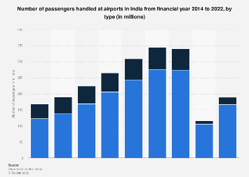

**MARKET STRUCTUREs AND its IMPLICATIONS :**

The aviationi industry in India has become one that is rapidly expanding. The industry had made a name for itself as a reliable, reasonably priced alternative to tiresome, protracted road or train trips. It was predicted that India would rank among the iworld's greatest aviation markets by i2034 due to a clear growth tendency. The passenger airline IndiGo led the industry with over 55% market share as of the financial year 2022.

The market leader is IndiGo-

Over 188 million passengers were handled by the Indian aviation industry at Indian airports in the same year. After IndiGoi, Jet Airwaysi had the greatest marketi share as of 2018. The former passenger airline, however, had to halt operations in April 2019 due to financial issues, opening the door for the latter with little opposition from other market participants.

One of the factors contributing to Indigo airline's relativei success in Indiai has been credited to its low costi and no-ifrills iapproach to domestic travel. . According to the Directorate-General of Civil Aviation, IndiGo transported over 46.6 million passengers during the fiscal year 2022. It ranked fourth among the country's most punctual airlines, with nearly 84 percent of its arrivals occurring on schedule. Because IndiGo was a carrier that also had the fewest complaints from customers, it enjoyed great popularity among its domestic base and would continue to grow in the years to come.

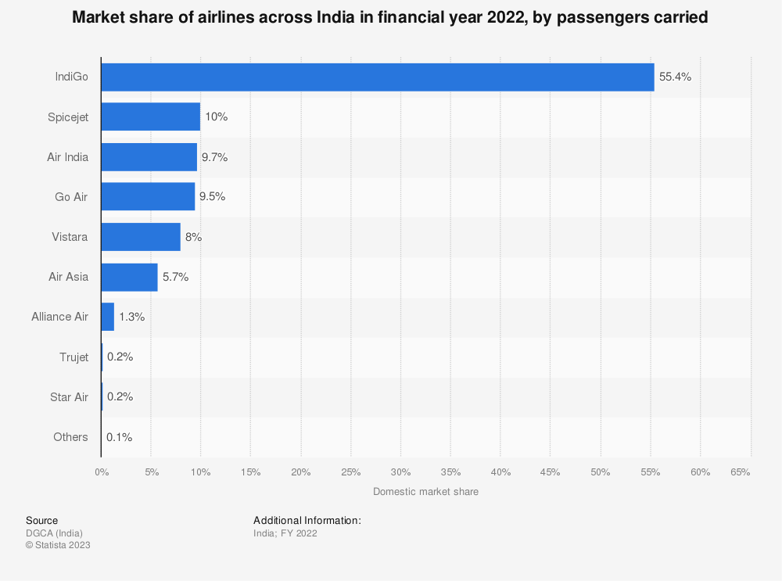

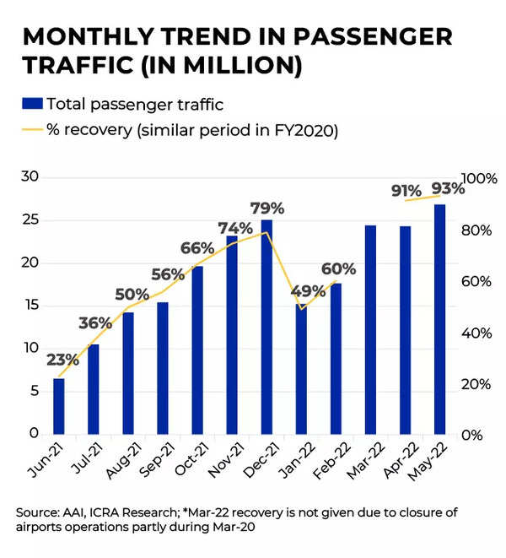

|  |  |  |  |  |  |
| --- | --- | --- | --- | --- | --- |
| **YEAR** | **DOMESTIC**  **PASSENGERS**  **(MILLION)** | **GROWTH**  **RATE**  **(%)** | **INTERNATIONAL**  **PASSENGERS**  **(MILLION)** | **GROWTH**  **RATE**  **(%)** | **TOTAL PASSENGERS**  **(MILLION)** |
| 2011-12 | 57.60 | 29.72 | 40.30 | 48.16 | 97.90 |
| 2012-13 | 60.60 | 5.20 | 43.10 | 6.94 | 103.70 |
| 2013-14 | 70.10 | 15.80 | 45.70 | 6.03 | 115.80 |
| 2014-15 | 85.20 | 21.54 | 49.80 | 8.97 | 135.00 |
| 2015-16 | 106.35 | 24.82 | 56.73 | 13.89 | 163.07 |
| 2016-17 | 128.60 | 20.92 | 69.65 | 22.79 | 198.25 |
| 2017-18 | 148.75 | 15.43 | 84.92 | 21.92 | 233.37 |
| 2018-19 | 172.20 | 15.99 | 98.76 | 6.37 | 270.96 |
| 2019-20 | 103.70 | -39.77 | 54.70 | -44.61 | 158.40 |
| 2020-21 | 53.31 | -48.30 | 8.81 | -83.42 | 98.43 |
| 2021-22 | 84.23 | 58.01 | 21.2 | 140.63 | 105.43 |
| **MEAN** | **102.27** |  | **55.93** |  | **157.48** |
| **CAGR(%)** |  | **9.645** |  | **0.5** |  |

The international passengers were 40.30 million in the year 2011-12 which increased to 270.96 million in the year 2018-19. The CAGR indicates that the compound annual growth rate for domestic passengers has been 10 percent in comparison to CAGR of 8 percent in respect of international passengers before Covid crisis in the world but it has been predicted that as the crisis end the market will start with boom.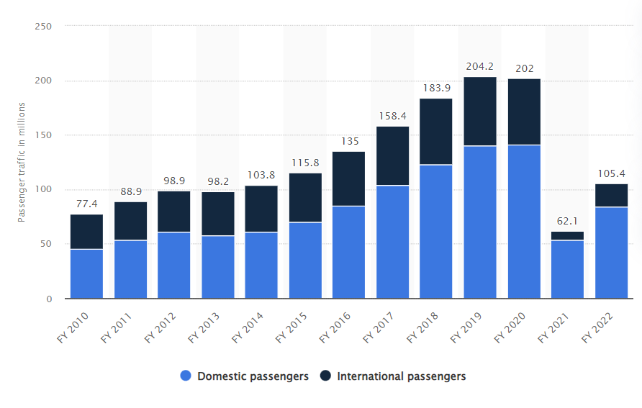

While the number of passengers flying in India increased by 21.4% to 1.28 crore from the previous year, key airlines including Interglobe Aviation, Spicejet, Air India, and GoFirst suffered a decline in their passenger load factors (PLF). The information showed that Air India's market share for March decreased slightly from 8.9% to 8.8%. In a similar vein, its PLF decreased month over month from 89 to 85.1%.

Vistara increased its market share from 8.7% to 8.9%, making it a winner. On the other hand, its PLF dropped from 92.8% to 91.6%.

Interglobe Aviation, also known as Indigo, followed Vistara's lead and saw a rise in market share, going from 55.9% to 56.8% month over month.

Additionally, GoFirst observed a decline in PLF from 93.1% to 90.2%.

However, India's aviation industry is expanding considerably.Despite the fact that most of the top airlines lost market share in March, the number of passengers flying within the nation increased by 21.4% to Rs1.28 crore compared to the same month last year.

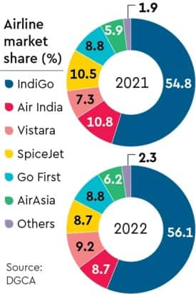

GROWTH IN PASSENGER TRAFFIC CARRIED BY SCHEDULE CARRIERS

(2011-12 to 2020-21)

Year Domestic

Passengers

(Million)

Growth

rate(%)

International

passengers(Million)

Growth

rate(%)

Total

Passengers(Million)

2011-12 57.60 29.72 40.30 48.16 97.90

2012-13 60.60 5.20 43.10 6.94 103.70

2013-14 70.10 15.80 45.70 6.03 115.80

2014-15 85.20 21.54 49.80 8.97 135.00

2015-16 106.35 24.82 56.72 13.89 163.07

2016-17 128.60 20.92 69.65 22.79 198.25

2017-18 148.45 15.43 84.92 21.92 233.37

2018-19 172.20 15.99 98.76 6.27 270.96

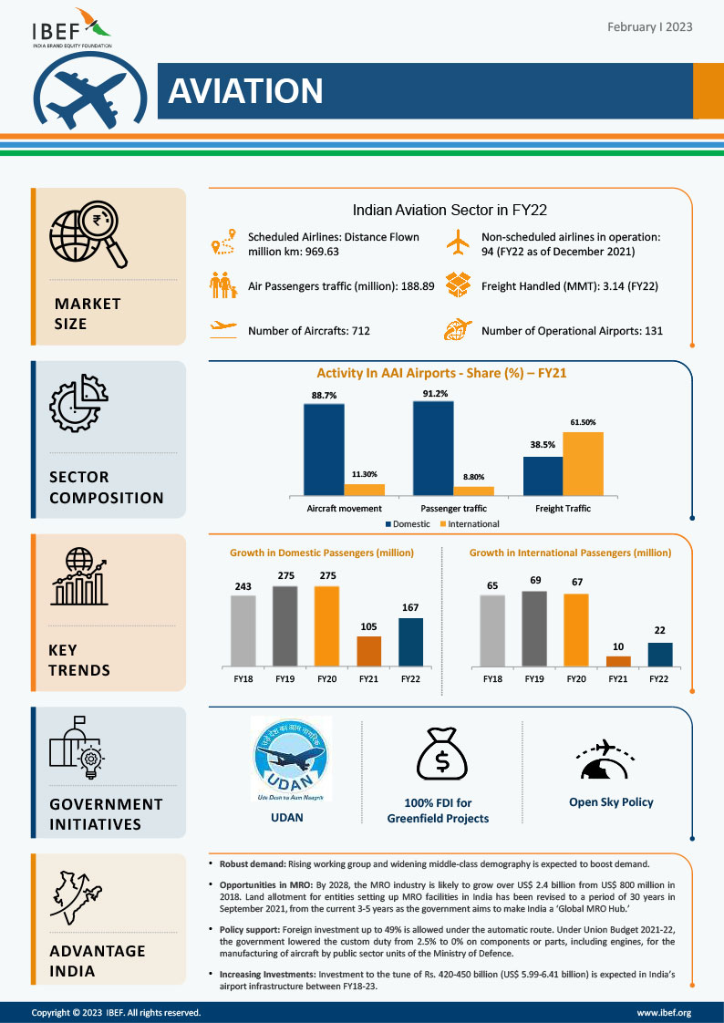

**Trends in International & Domestic Civil Aviation:**

**Fuel Cost Ratio Till Year 2022-**

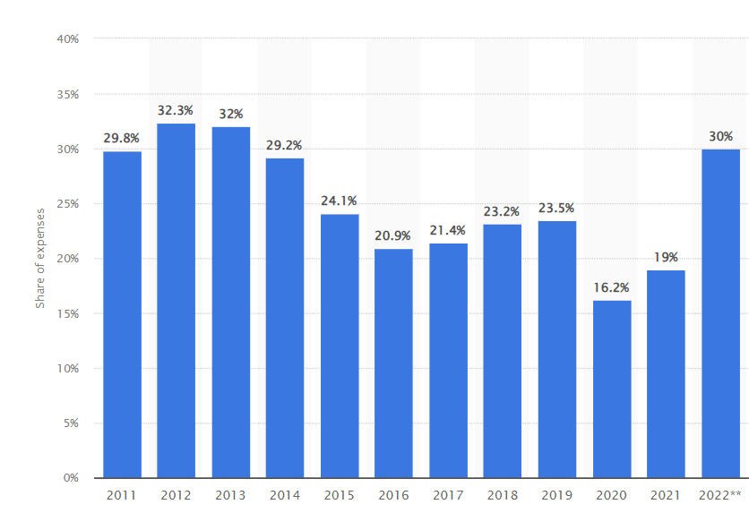

**Total fleet and lease percentage for airlines in India for Year 2022-**

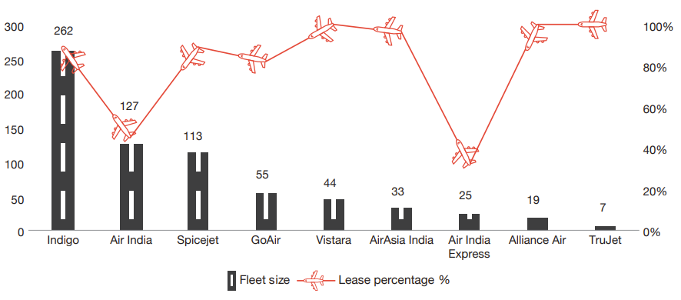

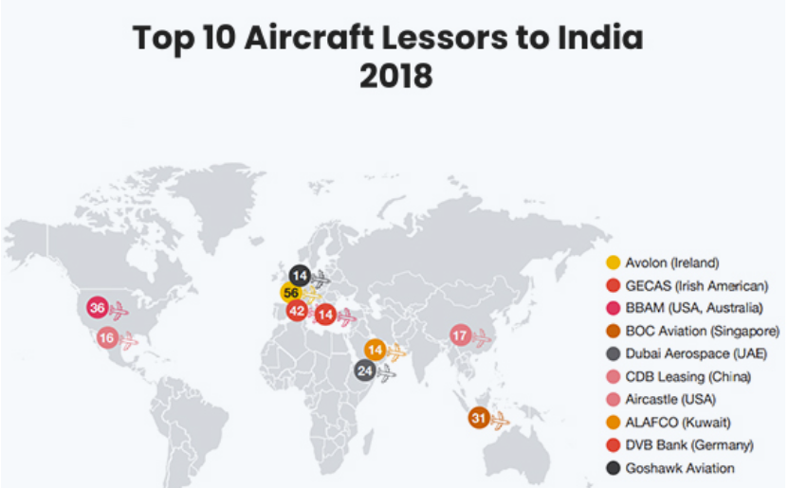

PROJECTED FUTURE:

India is the world's third-largest domestic aviation passenger market. India's domestic aviation industry is predicted to reach $30 billion by 2024, placing it third globally. A rising share of middle-class households, robust competition among low-cost carriers, infrastructure development at major airports, and a supportive political environment have all benefited the aviation business. India has a vast network of international flights in addition to domestic flights, and it now has air services agreements with 116 nations. Domestic passenger numbers increased at a CAGR of 14.5% over the course of six years, from FY14 to FY20, more than quadrupling from 120 million to over 275 million.

Indian airlinesi are expected to boost capacityi by at leasti 25%i, making Indiai the aviationi marketi with the quickest rate of expansion (7% annual growth) by 2040. As a result of the Covid crisis in 2020 and 2021, iair passenger itraffic in India increased by i47% to 123.2 iMillion passengersi in i2022. Additionally, it is anticipated that domestic aviation traffic to return to pre-covid levels in FY23 at 97%. In March 2022, iIndia's domestici revenue ipassenger kilometres grewi 32.3% iyear over year.

The lofty policy objectives that the Indian government has announced may have a long-term impact on the aviation industry.

Additionally, it is anticipated that domestic aviation traffic to return to pre-covid levels in FY23 at 97%. In March 2022, iIndia's domestici revenue ipassenger kilometres grew i32.3% year over year.

The Indiani government has unveiledi some bold policy goals that could have a longi-iterm effect on the aviation sector. Over the previous eight years, the nation's aviation connections have greatly improved. In the past 8.5 years, the government has built twice as many airports, from 74 in i2014 to i148 at today, enabling airi connectivity to many Tier-2i and Tier-3i cities.

By 2033, metropolitani airportsi are expected to accommodate 959 million passengers, or roughly 57% of all predicted travel, down from their current 62%, while itraffic in smalleri towns and citiesi is expected to more than triple. By 2025, the Indian government wants to increase the number of airports in the countryi, to 220. In addition, therei are plans to construct 15 new flying schools, 33 new domestic freight ports, and a focus on unmanned aircraft systems.

Civil aviation in India is one of the nations fastest-growing businesses, with a imarket of USi$ 900 million. India accounts for more ithan i65% of all traffic in iSouth Asiai. Major city airports already handle more than 340 million people annually, or more than 60% of all traffic.

India is on course to surpass the United States as the third largest consumer of commercial iaircraft with a fleet of 713 aircraft and an order book of over i1000 commercial aircraft. Indian airlines want to triple their fleet's carrying icapacity to around i1,100 aircraft by 2027.

The 137 airports managed by the AAI include 24 international, 80 domestic, 23 domestic defence airfields, and 10 customs. India now has 450 airstrips, however only 100 of them are fully operational. With 62% of the nation's overall aviation market, metro airports like Delhii, Mumbaii, Kolkatai, Chennaii, Hyderabadi, and Bangaloreihave dominated the industry.

**ROAD AHEAD-**

The fact that India is currently the third-largest domestic civil aviation market in the world is evidence of both the market's strength and potential as well as the inherent advantages of the Indian aviation industry: Innovation, flexibility, and adaptation. This is true despite the difficulties brought on by the Covidi-19 pandemic. But right now, India's legitimate objective is to dominate the global iaviation sector. Nevertheless, imanyi of thei brown-field and green-field airports now present in tier 2i and tier 3i towns and citiesi are projected to be the isector's future growth drivers and are anticipated to become significant airports.

Maximising the immense potential of these airports would depend heavily on properly organised Public Private Partnership (PPP) models and policy-level actions. Continuing funding for airports under the UDAN programme is one of the interventions, along with flexibility in capital investments and regulatory changes.

According to the International Air Transport Association (IATA), India will overtake China and the United States to become the third-largest air passenger market in the world by 2030. The sector's growing demand has also led to an increase in the number of planes operating there. 1,100 aircraft are expected to be in use worldwide by 2027.

**PRESENTATION OF DATA, ANALYSIS & FINDINGS-**

ANALYSIS OF OPERATIONAL EFFICIENCY: The study of a corporate organization's capacity to increase sales revenue and reduce costs is referred to as operational efficiency. It aids in determining how effectively profits are generated in relation to operating expenses. It simply refers to transactions carried out with large profit margins or in order to save costs. Every corporate organisation typically strives to maximise income in order to thrive and expand in the market. The use of economies of scale might improve it. When conditions permit an organisation to engage in transactions and offer services at a cost that gives them a just return on their real outlays, such organisation is often seen as operating efficiently.

The term "economic efficiency" refers to a state of affairs where resources are allotted as efficiently as possible. It implies that every resource unit is used to the fullest extent possible in order to reduce resource waste and maximise efficiency. Simply said, the services are offered for the least amount of money possible.

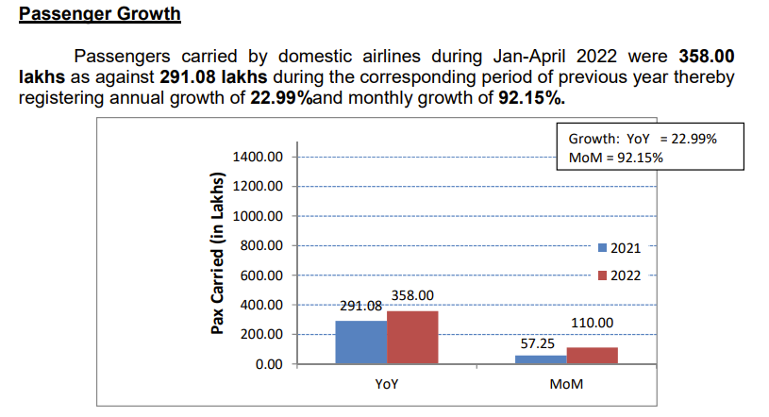

Freighti traffic increasedi at a CAGRi of 2.52%i betweeni FY16 and FY22i, rising ifrom 2.70 MMTi to 3.14 MMTi. 2,390,320 tonnes of goods were moved during FY23 (April–December 2022). India's airports could manage 17 MT of freight traffic by FY40. In FY22 (April–December 2022) there were 1,757,112 aircraft movements, while in FY23 (April–December 2022) there were 2,029,090 movements. In an effort to accommodate the rising aviation traffic, the Indian government has been attempting to construct more airports. In operation as of 2022 were 131 airports in India. In India, 220 operational airports are planned to be open by 2025.

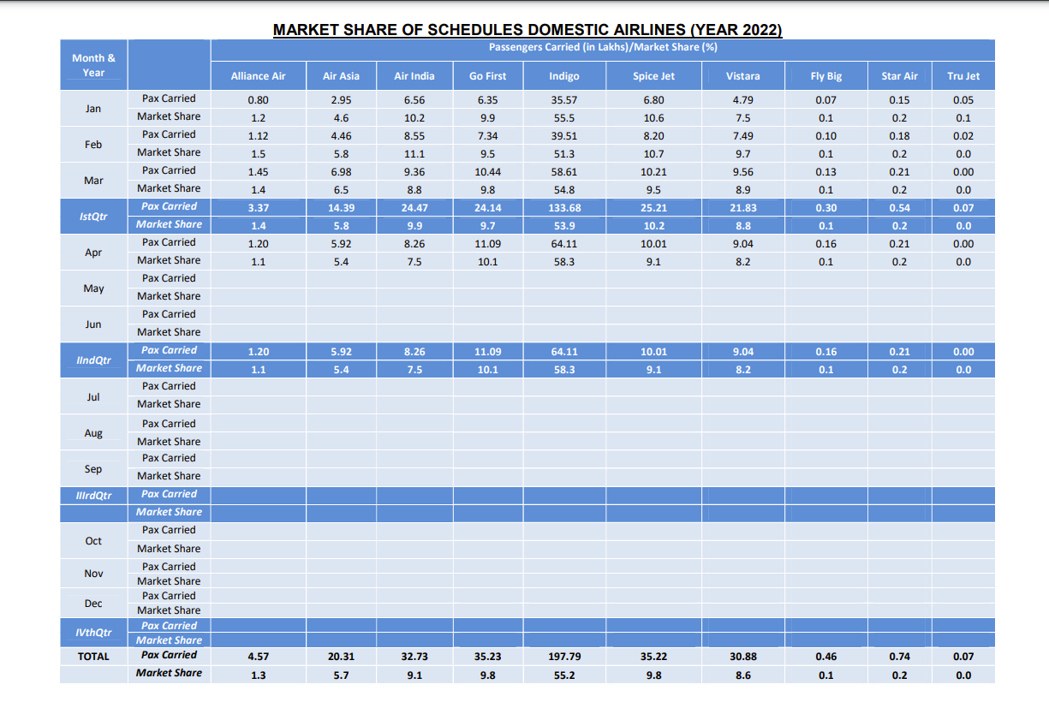

**ANALYSIS OF PROFITABILITY RATIO :**

Financial measures known as profitability ratios are employed to assess a icompany's capacityito earn revenues in irelation to its outlays and other pertinent costs incurred over a given time period. Simply said, profitability is the ability to turn a profit. For these ratios, it is typically believed that a igreater numberi in comparisoni to a icompetitor's ratioi or to a comparable ratioi from the prior periodi denotes an organization's isuccess.

**NET PROFIT RATIO:**

The link between net profit and sales is defined by the net profit ratio. The company's stockholders depend on net profit as a source of income, so they pay close attention to this ratio.

If a company's net profits are low or negative, it can lead to a variety of issues, from declining sales to a bad customer experience. The better it is, the bigger the net profit ratio. A high ratio demonstrates both the company's operational effectiveness and how well its affairs are managed. An improvement in the ratio over the prior years is a sign of the company's operating effectiveness and profitability as a whole. It aids in determining how profitably the assets have been utilised over the specified time.

**PROVISION OF SERVICES OF DTFFERENT CATEGORTES OF ROUTES UNDER ROUTE DISPERSAL GUIDELINES {RGDs):**

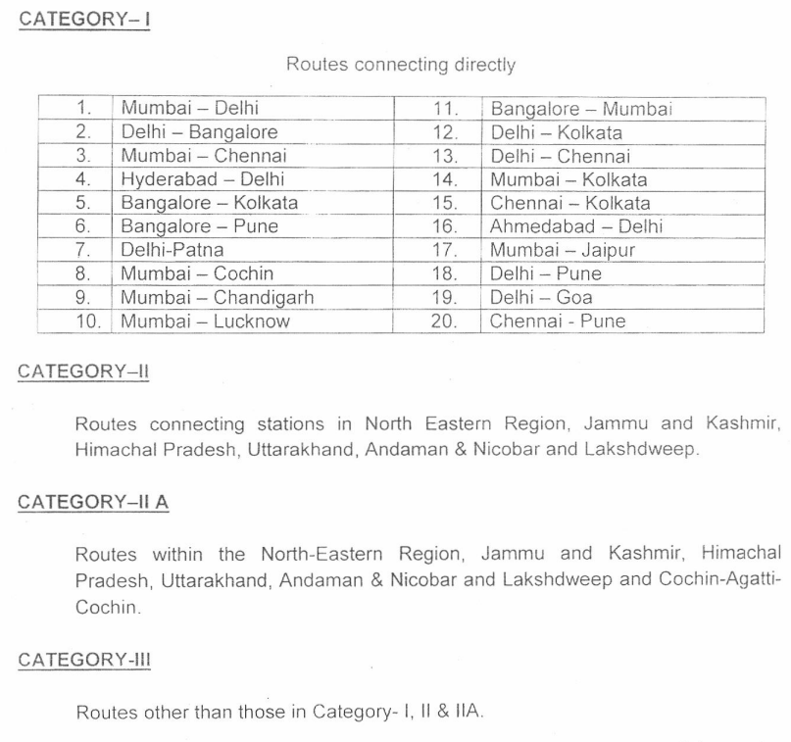

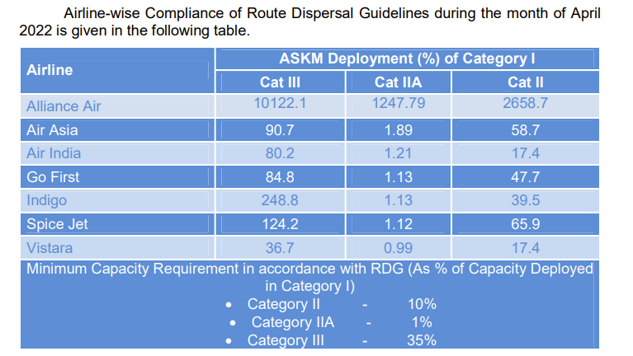

**On-Time Performance (Scheduled Domestic Airlines)** –

For four metro airports, namely Bangalore, Delhi, Hyderabad, and Mumbai, On-Time Performance (OTP) of scheduled domestic airlines has been calculated. For the month of December 2022, the airline OTP at four metro airports is as follows:A picture containing text, screenshot, line, number

Airport-wise On-Time Performance of scheduled domestic airlines complying with Route Dispersal Guidelines is as follows:

1. **AIR INDIA-A picture containing text, screenshot, line, number

   Description automatically generated**
2. **ALLIANCE AIR-**

1. **SPICEJET-**

1. **GO FIRST-**

1. **INDIGO-**

1. **VISTARA-**

1. **AIR ASIA-**

# **TRAFFIC FIGURES FOR 2022-**

**Revenue Earned & Seats Sold in Highest Fare Bucket –**

Thei revenue earnedi and the numberi of seats sold by ischeduled airlinesi in the highest fare bucket on selected 20i sectors is as follows:

1. **AIR INDIA:**

1. **INDIGO:**

1. **GO FIRST:**

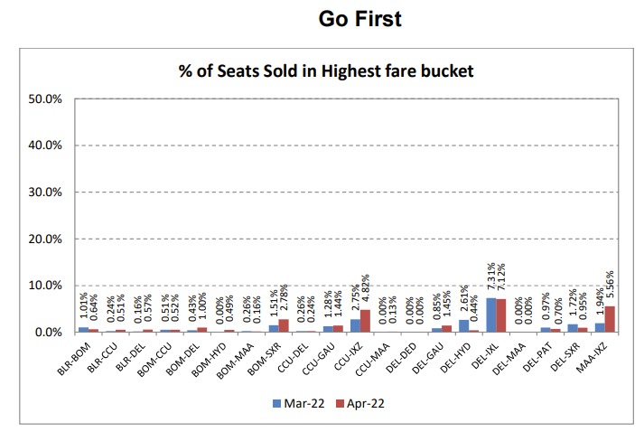

1. **SPICEJET:**

1. **VISTARA:**

1. **AIR ASIA:**

**Compliance with CAR Section 3, Series M, Part IV –**

**Under CAR Section 3, Series M, Part IV, airlines are required to report statistics on the number of rejected boarding cases, cancellations, and delays, as well as the status, on a monthly basis.**

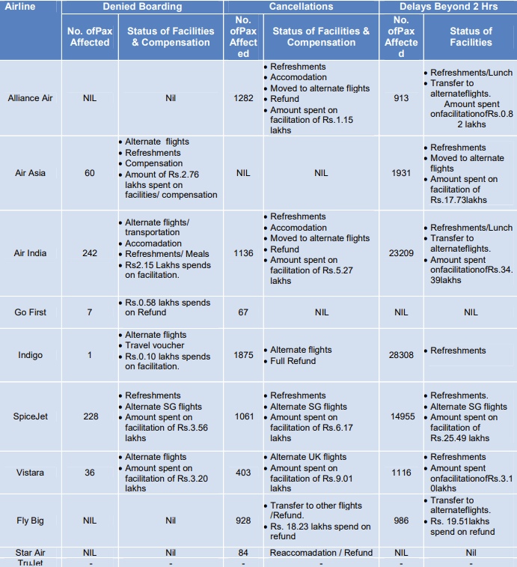

**FINDINGS:**

1. **Domestic: Passenger Load Factor from Jan 2022 to Dec 2022 in the chart:**

1. **Number of Flight from September 2021 to Dec 2022 in the chart:**

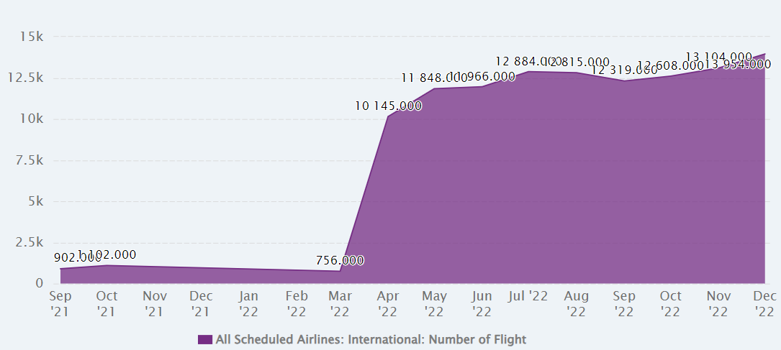

1. **Aircraft Kilometer Flown from March 2021 to December 2022 in the chart:** **A picture containing text, screenshot, purple, lilac

   Description automatically generated**

**Complaints and Redresal Status of Airlines in India for year 2022:**

**SUMMARY OF THE FINDINGS-**

1. **FUEL COST RATIO-**

* The cost of jet fuel grew by around 75% to USD 136/bb in 2022 as a result of rising crude oil prices as well as a larger spread for jet crack. Both of these are anticipated to decline from their peak levels in 2022.
* The price of Brent crude oil is predicted to fall from just over $100 per barrel in 2022 to around $80 per barrel this year. It is projected that the fracture spread will reduce from 35% to roughly 23%, which is still a little higher than the long-term average.
* Recent results have shown both of these trends (see chart below). Over the course of 2023, the price of jet fuel is predicted to average around USD 98.
* As the continuous recovery in traffic numbers works to counteract the lower fuel price and smaller crack spread, the global airline industry's fuel expenditure is predicted to reach USD 215 billion this year, or around 28% of operating expenses. In 2022, operating expenses were roughly 30% fuel-related.

• It is predicted that the industry will experience net losses of USD 3.6 billion in 2022 before turning a profit of USD 9.8 billion in 2023. This profit works out to roughly USD 2.25 per traveller.

1. **LEASE RENTAL COST RATIO-**

* The research indicates that the airline reduced its expenditure over lease rental ratio in the 2019–20 fiscal year, despite this, the number of net sales increased this year. This is in relation to the growth of lease rents expense. The data for growth rate shows that Indigo Airlines spent a lot on lease rental costs in the year 2020–21, as the percentage increase in spending this year was higher than it was in previous years, but it also shows that sales have increased at a rate that is consistent with the airline’s forecast for 2021-2022.
* As of August 2021, the Boeing 747-8F was the most costly new aircraft to lease. The average lease cost for the freighter aircraft model was more than 1,300 dollars. With a lease cost of little over 1,200 dollars, the Airbus A380 was the second most costly aircraft.
* A screenshot of a computer

  Description automatically generated with medium confidence

1. **FINANCE COST RATIO-**

* The most recent financial figures demonstrate that in Q3 2021, the industry's operating profitability was less under pressure. The operational loss in the sample of 87 airlines decreased from 13.6% of revenues in Q2 to 2.6% in Q3.
* In January 2022, the Global Airline Share Price Index increased as a result of investors' optimism that Omicron-related disruptions might not have the negative effects on the travel sector that had been anticipated. But the index is still 30% below pre-crisis levels.
* The price of jet fuel has also increased since the Omicron-related decline in December to its highest level since late-2018.
* Just as newly imposed travel restrictions are having a negative impact on travel demand, the increased price is putting additional pressure on airlines' operational costs.

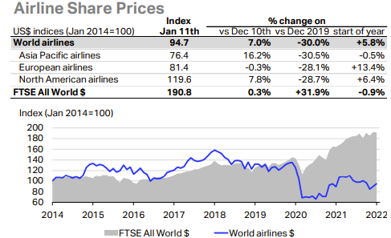

1. **NET PROFIT RATIO-**

Net profit margins grew from i39.7% in i FY21 to i 23.8% in i FY22.

i Debt to Equity i ratio for FY22 i stood at -0.1 as compared to 5.0 i in FY21 i

**Contribution of Aviation Sector in the GDP-**

The airline sector has faced challenges in the last ten years, such as growing ATF costs, airlines going out of business, and overcrowded airports. However, the sector has begun to realise its innate development potential. The number of middle-class people is expanding, and they have more money to spend, which has greatly increased passenger traffic. The demand for services in civil aviation increased as a result of the rise in annual travel. The Central Government has handled this desire in a number of different ways. Not only did it increase the FDI ceiling for the sector, but it also permitted foreign airlines to participate in India's airline sector for the first time.

According to a research i, the aviation industry i today supports 1.7 i million jobs i in India and contributes i Rs 33,000 crore, or i 0.5% of the GDP i, in addition to building much needed key infrastructure.

This contribution is anticipated to rise even higher as the industry recovers from a number of challenging i years in i which many businesses i sustained losses as a result of the i RS 87,500 crore in i social security i and tax i obligations.

The analysis anticipated an additional Rs 16900 crore in government income to measure the Indian economy through indirect and induced taxation.

The sector indirectly contributed through the supply chain Rs 10,700 and Rs 14,700 through its direct production. Additionally, the i Oxford University i joint venture contributed an additional Rs 58,200 crore for tourism-related catalytic benefits, bringing its total to Rs i 91,200 crore or 1.5 i percent GDP consultancy i.

Additionally, it claimed to have supported 276,000 direct jobs, 841,000 indirect jobs through its supply chain, and a further 605,000 jobs through sector employees' spending, in addition to the employment of an additional 7,1 million people as a result of catalytic impacts like tourism.

Recognising that the Indian airline transports 71% passengers and 77% freight, it can be seen how these two factors have a multiplicative impact on the GDP, wages, profits, and tax income that Indians generate.

**Contribution of Aviation Sector in the INDIAN GDP-**

The number of middle-class people is expanding, and their disposable income has increased, which has greatly increased passenger traffic. Not only did it increase the FDI ceiling for i the sector i, but it also permitted i foreign airlines to participate in i India's airline sector for the first time. According to a survey, the aviation industry supports and supports 1,7 million jobs in India and generates Rs i 33,000 crore, or 0.5% of the GDP, in addition to building key infrastructure that is urgently needed. The study anticipated an additional Rs 16900 crore in government income to measure the Indian economy through i taxation via indirect i and induced channels i.

India's aviation industry currently makes up $72 billion of the country's GDP. In order for the ecosystem to develop and for government initiatives to be effective, demand must increase. Furthermore, the Indian government takes the lead in promoting mass aviation under the National Civil Aviation Policy 2016 (NCAP). It accomplishes this by increasing its affordability. They also support e-governance, deregulation, streamlined processes, and business. through induced and indirect pathways.

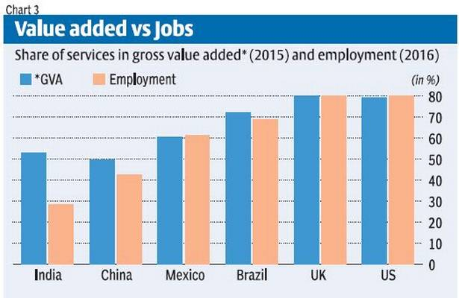 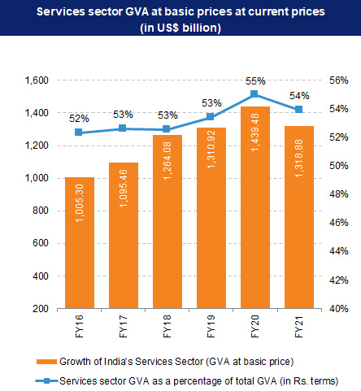

**CONCLUSION, RECCOMENDATIONS & BIBLOGRAPHY**

**CONCLUSION-**

The Indian civili aviationi marketi, which is currentlyi the 9th largest marketi in the worldi, has been predicted to experience exponential growth in the next years. Civil aviation in India is one of the nations fastesti-growing ibusinesses, with a market of USi$ 900 millioni.

India accounts for more than 65% of all traffic in South Asia. Major city airports already handle more than 340 million people annually, or more than 60% of all traffic.

India is on course to surpass the United States as the third largest consumer of commercial aircraft with a fleet of 713 aircraft and an order book of over 1000 commercial aircraft.

Indian airlines want to triple their fleet's carrying capacity to around 1,100 aircraft by 2027. The Airports Authority of India (AAI) oversees 137 airports, including 24 international, 80 domestic, 23 domestic defence airfields, and 10 customs facilities. India now has 450 airstrips, but only 100 are completely functional. Metro airports like Delhi, Mumbai, Kolkata, Chennai, Hyderabad, and Bangalore have dominated the business, accounting for 62% of the country's total aviation market.

India will carry more than 1.3 billion passengers annually during the next 20 years. The country currently has 148 airports and is ranked third in the world for domestic travel in terms of seat capacity. By March 2023, IndiGo had a 56.8% market share in the domestic market, followed by Vistara (8.9%) and Air India (8.8%).

By 2025, three public-private partnership (PPP) airports in Delhi, Hyderabad, and Bengaluru would have invested INR 30,000 crores in new constructions.

**Key investments and development-**

* The Department for Promotion of Industry and Internal Trade (DPIIT) reported that FDI investment into India's air transport sector (including air freight) totalled USi$ 3.61 billion between April 2000 and September i2022.
* The government has approved 100% FDI through the automatic route in ischeduled iair transport service, regional air transport service, and domestic scheduled passenger carriers. However, FDI above 49% would require government approval.
* In the next five years, AAIi and other airporti developers hopei to invest overi Rs. 98,000i crores in the airporti industry.
* There will probably be 24 PPP airports by 2024, up from five in 2014.
* In the next four years, it's anticipated that India's aviation sector will get investments totaling Rs. i 35,000 crores (USi$ 4.99 billion). i By 2026, the iIndian govt intends to invest USi$1.83 billioni in airport iinfrastructure development and iaviation navigation services.
* By 2025, India wants to have 220 new airports, according to iMinister of iCivil Aviation Mr. Jyotiradityai Scindiai. In the upcoming years, 133 new flights will increase perishable food cargo flights by 30%.
* Apollo Global, a private asset management located in the US, helped Mumbai International Airport Ltd (MIAL) i raise $750 million in debti in 2022 through a private iplacement.
* In iMay 2022, Adani Airport Holdingsi (AAHL) raised $250 imillion for icapital expenses and the construction of 6 airports.
* A 1.2% net profit margin is predicted for the airline industry in 2023, which is more than idouble the iprevious prediction of $i4.7 billion (DEC 2022).
* Operating earnings for the airline sector are predicted to reach $22.4 billion in 2023, a significant increase from the December prediction of an ioperating profitiof $i3.2 billion. Additionally, it is morei than twice as large as the $10.1 billion operational profit target for 2022.
* In 2023, 4.35 billion individuals are anticipated to travel, approaching the 4.54 billion who did so in 2019.
* With a steep slowdown in international trade volumes, cargo volumes are predicted to be i57.8 million tons, which is below the i61.5 million tons icarried in i2019.
* The total income is anticipated to increase by 9.7% year to $803 billion. Since 2019 ($838 billion), when industry revenues last exceeded $800 billion, this will be the first time. It is anticipated that annual expense growth will be limited to an increase of 8.1%.

.**RECCOMENDATIONS-**

In the ilast few idecades, the Indian aviation iindustry has expanded quickly in terms of passenger volume, airports, flights, and investor base. The domestic scheduled airlines, on the other hand, have struggled to raise money over the years and have struggled to remain profitable.

The following are the recommendations to the domestic scheduled airlines to survive in the market and to create:

* According to the survey, airlines must spend a lot of money on fuel and electricity. The price of petroleum products on the global market determines how much power and fuel cost. The airlines might not be able to try to keep costs under control in this area. However, as the airlines' capacity utilisation increases and they add more planes, they may eventually be able to lower their fuel and electricity costs.
* According to the survey, airlines were unable to meet their operating costs, which led to operating losses. Therefore, these airlines should concentrate on making efficient use of the operating expense costs incurred.
* Another significant aspect that will help airlines do better in the long run is the rise in per capita income and the lack of time among the working class.
* Despite the current decline in air travel, pandemic airline firms ought to seize this chance to suggest some cost-effective alternatives to laying off staff in order to decrease costs.
* Creating additional routes for locations that are now not connected by airlines will also give them an opportunity to boost revenue and, consequently, profitability.
* The iongoing initiatives under thei UDANi initiative must be finished iin a timely manneri. The International UDAN programme should also increase the capacity that international airports now have.
* The government's plan to turn India into a imajor provideri of aircrafti maintenancei, repairi, and overhaul (MRO) i services will enable airlines to operate more profitably and efficiently.
* Additionally, there should be long-term advantages and economies of scale as a result of the convergence of civil MROs and the defence industry.
* The creation of longi-iterm plans for cutting-edge iaviation technology research willi aid ini the development of a manufacturing ecosystem in the nation.



**BIBLOGRAPHY-**

**Annual reports -**

• IndigoAirlines

• SpiceJet

**Websites**

• www.google.com

• [www.wikipedia.in](http://www.wikipedia.in)

• [www.goindigo.in](http://www.goindigo.in)

• [www.spicejet.com](http://www.spicejet.com)

• www.airindia.in

• [www.sceibed.in](http://www.sceibed.in)

• [www.telegraph.co.uk](http://www.telegraph.co.uk)

• [www.investindis.gov.in](http://www.investindis.gov.in)

• [www.ibef.org](http://www.ibef.org)

• [www.shodhganga.inflibnet.ac.in](http://www.shodhganga.inflibnet.ac.in)

• [www.hindustantimes.com](http://www.hindustantimes.com)

• [www.livemint.com](http://www.livemint.com)

* www.ibef.org/industry/indian-aviation